**English Policy**

**2024-2025**

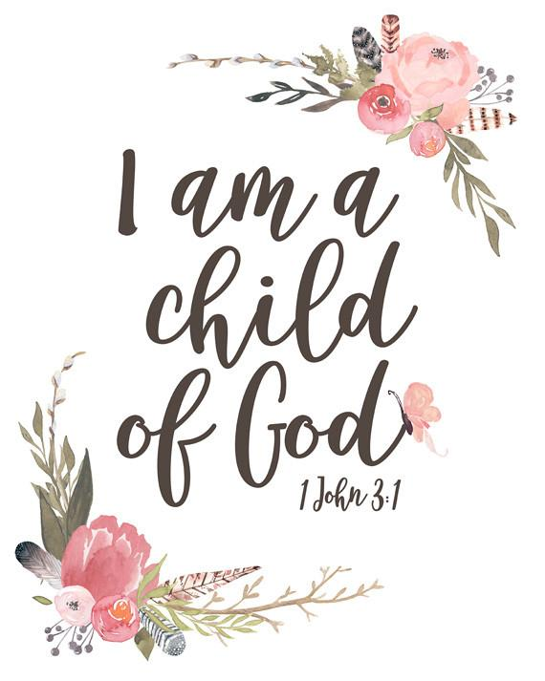

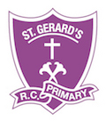

**St Gerard’s Catholic Primary School**

*“Guided by God, we learn to love, hope, dream and achieve.”*



**SAFEGUARDING STATEMENT**

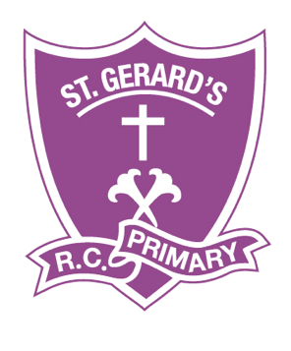

**“St Gerard’s Catholic Primary and Nursery School is committed to safeguarding and promoting the welfare of children and young people and expects all staff and volunteers to share this commitment”.**

**STATEMENT OF INTENT FOR ENGLISH**The teaching of English at St Gerard’s is designed to instil in children a love of speaking and listening, reading and writing that will last them a lifetime! In order to engage fully with the curriculum, and to achieve the higher levels of written and spoken communication expected in the world today, literacy skills must be carefully nurtured. St Gerard’s Catholic Primary & Nursery School aims to ensure that **all** of our children are given the learning opportunities to achieve their full potential, in all areas of English. 

We believe that the development of secure, confident language skills in our pupils is critical to their future, and to their ability to be happy and successful in life beyond the classroom. We are committed to ensuring that pupils learn to enjoy reading, writing and speaking, to appreciate the world of books, and to feel pleasure in writing creatively. Giving pupils the key skills in English enables them to access material in all curriculum areas, and provides a foundation for their learning throughout their school career and beyond!

**IMPLEMENTATION**

**ENGLISH CURRICULUM AIMS**

* To ensure that all children have access to a creative, inspiring literacy curriculum.
* To develop each child’s confidence in the use of language both orally and written.
* To enable our children to become fluent readers and encourage a lifelong love of reading.
* To provide opportunities to write in a wide range of contexts and for different purposes.
* To encourage and value the use of drama, role play, debate and speaking exercises to support children with their writing.
* To build positive attitudes towards reading, writing, speaking and listening and within all curriculum areas.

**WRITING**

From year 1 to year 6, writing is taught daily using the Pathways scheme of work. The scheme uses high quality, imaginative texts that excite and inspire the children. The use of ‘mastery keys’ allows children to use high level vocabulary and a wide variety of punctuation with confidence. The Pathways scheme provides regular opportunity for extended writing, building children’s writing stamina. Teachers model writing skills, spelling skills and phonics skills as part of our daily English lessons, supporting individuals and groups to develop these skills as they move through each unit. At the end of each unit, children complete an assessed piece of independent writing which is then used in moderation and pupil progress meetings to support our assessment judgements. We also use the Pathways to Spell scheme to support our children’s understanding of spelling rules, appropriate to their developmental stage. Writing is celebrated regularly in our celebration assemblies through Head Teacher’s awards and in the displays both in the classroom and around the school. Writing is not only evident in English books, but also in wider curriculum areas. Children are provided with a range of activities in which they can demonstrate their English understanding in a range of subjects. We also recognise the importance of writing from a personal perspective, using their own experiences. Our children write about the huge variety of school trips and events they experience.   
  
Within the Early Years Foundation Stage, emergent writing is encouraged using a wide range of different writing materials and with a broad range of purposes such as letters, postcards, lists, menus and labels. As soon as children enter our nursery they are encouraged to mark make in a variety of different ways through continuous provision activities. The importance of fine and gross motor skill development, in order to write confidently, is paramount. Children take part in many different activities throughout the day to build these skills, in order to be ready to write accurately, neatly and comfortably. Daily Read Write Inc phonics sessions give children the sound knowledge and skills to spell words phonetically, as well as spelling some simple high frequency words with increasing accuracy.

Children participate in daily handwriting activities across the school, following the ISHA handwriting scheme. They are encouraged to treat their work with respect, writing neatly in all curriculum areas.  
  
**READING**  
  
Children entering our school in the Early Years Foundation Stage are welcomed in to an environment that is enriched with high quality reading experiences. Children regularly listen to stories and poetry in a variety of curriculum areas to engage their interest and stimulate their excitement. Early reading is delivered through the Read Write Inc SSP programme, with children accessing differentiated groups daily and those who have sound gaps receiving 1:1 tutoring. This continues up in to KS1, until the children complete the programme and are ready to move on to a guided reading programme. For children in years 2 – 6, guided reading sessions take place daily, using the Bug Club reading programme. The Pathways programme for writing uses high quality texts to stimulate writing experiences, at the same time as allowing children to listen to and enjoy stories being read to them by the class teacher.  
  
Reading is a focus in our curriculum, and opportunities for children to develop a love of reading are planned across the school year. We celebrate a reading week in the Spring term, running this closely to World Book Day. We visit our local library, invite a story teller in to school and have an Usborne Book fair, as well as reading challenges and sponsored reads. We are implementing ‘Reading Rockstars’ reading leaders leading reading for pleasure lunch time clubs and supporting the younger readers on their reading journeys.   
  
Home reading is an important part of our homework system. Children take home reading books that meet their phonic/fluency level and can progress to become ‘free readers’ in which they are then able to select any book from our school library to read. Children earn dojo points for regular reading at home, with their reading diaries signed. Parents are encouraged to read with their child at least 3 times weekly, and information is given via Class Dojo, our school website and at parents evenings to help parents support children with their reading.

**WRITING AND READING ACROSS THE CURRICULUM**

**Mathematics:**

Writing contributes to the teaching of mathematics in our school by giving opportunities to express their reasoning and understanding of mathematical concepts in written form for the teacher to read. This is often seen in children’s journalling skills. Reading skills are essential when children are completing reasoning activities, comprehending the questions they are reading.

**Personal, Social and Health Education (PSHE) and citizenship/ Mental Health and Wellbeing:**

Writing contributes to the teaching of some elements of personal, social and health education and citizenship. The children are encouraged to have high standards for themselves, recognising their strengths and also areas that they need to develop. Reading is an important part of our PSHE curriculum as we use the ‘No Outsiders’ programme, focussing on high quality texts, to teach crucial life skills of tolerance and acceptance to our children. This develops their inference skills.

**Science, Geography, History, ICT, DT, Art – ‘Topic’:**

The teaching of writing offers opportunities to support in every single curriculum area. It gives children the ability to express their opinions and show their understanding of topics they have covered in written form. Children apply their understanding of new technical vocabulary in written tasks. Reading is often used within topic lessons as children seek to find out new information, researching and comprehending what they have read.

**SUPPORTING SEND AND EAL LEARNERS**

We believe that reading and writing are essential skills for all children, and we strive to ensure that every child at our school is given equal opportunity to progress at their individual level in both reading and writing. All teachers/support assistants provide learning opportunities that are matched to the needs of children with learning difficulties and other barriers to learning. The children’s abilities/challenges within writing are reflected when writing individual support plans or differentiating the classroom provision within school. The SENDCo and EAL lead regularly liaise with class teachers regarding target setting for specific children, as well as providing CPD opportunities for staff to support with interventions and teaching tools to support learners with additional needs. We make good use of technology to support SEND and EAL learners, using talking tins, audio books in home languages and google translate to support.

**ASSESSMENT**

We assess the children’s writing skills whilst observing them working during a variety of different curriculum lessons, not just in English. Teachers complete one piece of assessed writing using our individual writing assessment sheets each half term, these are then used in pupil progress meetings. The use of ‘NFER’ tests in KS1 and KS2 also contribute to children’s assessment as do termly Read, Write Inc assessments. At the end of each term, we make a judgement against the National Curriculum skills identified as ‘ARE’ (Age-Related Expectations). The class teacher records the child’s attainment, and then uses this information to plan future work for each child. This method of recording also enables the teacher to make an annual assessment of progress for each child, as part of the child’s annual report to parents. Summative assessments are collated on the SONAR programme. We pass this information on to the next teacher at the end of each year.

**HANDWRITING**

Staff are to use and teach the ‘ISHA’ handwriting style. English books in KS1 and KS2 will have the ISHA handwriting lines in. The distance between the lines will be differentiated across the year groups from 0-4 line spacing. This also applies to handwriting books.

All classes are to follow the ISHA handwriting sequence of lessons. Handwriting should be taught each week and using handwriting books.

**SPELLING**

Staff will use the Pathways to Spell scheme in years 1-6. The sequence of lessons will be taught (including spelling rules). The Read Write Inc programme allows for spelling practice within each lesson, focusing on specific sounds, as well as giving opportunity to practice spelling high frequency words.

**MONITORING AND REVIEW**

The monitoring of the standards of children’s writing and of the quality of teaching in writing is the responsibility of the class teacher in additional to the English subject leader. The work of the subject leader also involves supporting colleagues in the teaching of writing and being informed about current developments in the subject. The English subject leader gives the Headteacher an annual summary report in which they evaluate the teaching and learning in the subject, and indicates areas for further improvement. The English subject leader has specially-allocated regular management time, which he uses to review evidence of the children’s work, monitor assessments and when instructed by SLT to undertake lesson observations of writing teaching across the school. Staff questionnaires are sent out, with the subject lead collating data and providing specific CPD as identified in the results.

**MODERATION**

Moderation takes place termly. In-house writing judgements are shared between staff and moderated accordingly using our writing assessment sheets. This ensures that all staff are working consistently to the same standard, and assessments are rigorous.

**SPOKEN LANGUAGE**

We recognise how important it is talk to children and expand their vocabulary and comprehension. Children who experience more child-directed speech become more efficient in processing familiar words and gain larger expressive vocabulary. To become a fluent, skilled, attentive reader starts at the earliest stages, driven by quality talk from adults.

The teaching of Phonics is crucial within the Early Years Foundation Stage and Key Stage 1 to provide children with the skills to decode and read with fluency. Children in EYFS and KS1 will use the ‘Read, Write, Inc’ phonics programme to develop these skills. The programme aims at teaching phonic sounds at a rapid pace, using a multi-sensory approach. The children are continuously assessed throughout the year and their learning is moved on at an appropriate pace. Children who are identified as having gaps in their knowledge are targeted in a one to one intervention programme. The children have focussed, daily sessions that build upon phonic decoding knowledge and the application of this in a structured reading session. Children in years 2, 3 and 4 who are not meeting the expectations for their year group will also access ‘Read, Write, Inc’ phonic/reading sessions daily, and those children who need further support in years 5 and 6 will use the RWInc ‘Fresh Start’ programme.

**IMPACT**  
  
At St Gerard's we are always growing and developing, our curriculum moves with the cohorts and pupil needs and we aim to ignite a passion for reading and writing in ALL of our learners by the time they leave us for secondary school! Our supportive, caring ethos provides children with the opportunity to experiment with language and genre, to step out of their comfort zone and to achieve to their greatest potential. Regular, ongoing assessment of learning allows gaps in knowledge to be addressed quickly and effectively to support and enable success for each child. Children are given the skills to communicate effectively across the curriculum, both verbally and in written form. Their successes are celebrated and respected by their peers. Our children leave us with literacy skills that will allow them to be successful and happy in their adult lives!