

St Gerard’s Catholic Primary and Nursery School

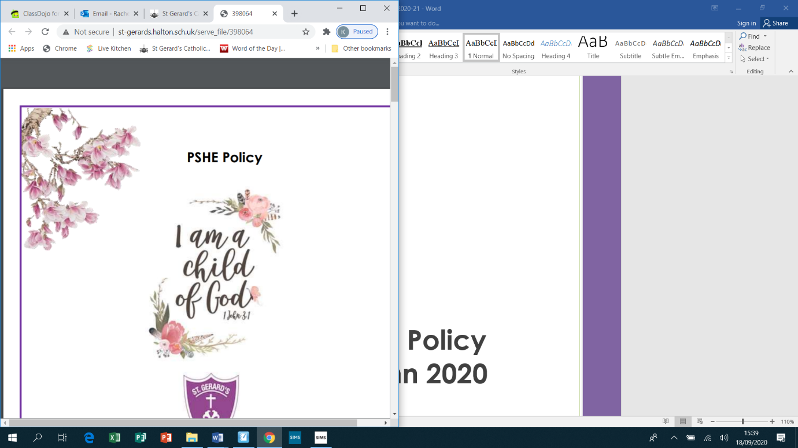

**Science Policy**

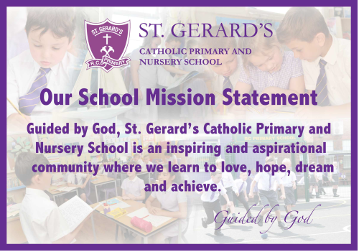

**SAFEGUARDING STATEMENT**



***“St Gerard’s Catholic Primary and Nursery School is committed to safeguarding and promoting the welfare of children***

***and young people and expects all staff and volunteers to share this commitment”.***

**Safeguarding incidents could happen anywhere and staff should be alert to possible concerns being raised in this school.**

**Science Policy 2024-2025**

**“The Scientist is not a person who gives the right answers, they are one who asks the right questions”**

* ***Claude Levi-Strauss***

**Policy Date: September 2024**

**Policy Status: Statutory**

**Policy Review Cycle: Annual**

**Next Review Date: September 2025**

The Subject Leadership role of Science at St Gerard’s is central to improving outcomes for our children. Subject Leaders at St. Gerard’s have high expectations of themselves and our children, and are passionate about their specialisms. The lead for Science shall ensure that the all teachers and external partners provide the best Science education for their pupils.

**Responsible to:**

**Governors, Head Teacher**

**INTENT:**Science is an integral part of modern living and makes an increasing contribution to all aspects of life in the modern world. Children are naturally fascinated by everything in the world around them and Science makes a valuable contribution to their understanding. Children learn by playing with things in their world. They pick up clues about what they see, touch, smell, taste and hear in order to makes sense of it all.   
  
Eventually they come to conclusions which they match up with all the experiences they have had. Teachers and parents/carers can help children to take a second, careful look at the world. By talking together children can be encouraged to explore and observe so that they can group objects and events and look for similarities and differences.   
  
They will need to measure and record the things they have found out in ways that make sense to them so that later they can talk to other people about what they have discovered. They should be encouraged to understand how science can be used to explain what is occurring, predict how things will behave, and analyse causes.  
  
**Aim:**At St Gerard’s Catholic Primary & Nursery School Science is taught as a discrete lesson and as part of cross-curricular themes when appropriate. Science has links with other areas of the curriculum including Geography, English, Maths, Art and Design Technology. The programmes of study describe a sequence of knowledge and concepts.   
  
While it is important that pupils make progress, it is also vitally important that they develop secure understanding of each key block of knowledge and concepts in order to progress to the next stage. Pupils should be able to describe associated processes and key characteristics in common language, but they should also be familiar with, and use, technical terminology accurately and precisely. They should build up an extended specialist vocabulary. They should also apply their mathematical knowledge to their understanding of science, including collecting, presenting and analysing data. The social and economic implications of science are important but, generally, they are taught most appropriately within the wider school curriculum: teachers will wish to use different contexts to maximise their pupils’ engagement with and motivation to study science.  
  
**Purpose**

* Encourage pupils to build on their own enthusiasm and natural sense of wonder about the world around them
* Promote opportunities for children to express their own ideas and be creative in their approach to science to help achieve enjoyment of scientific work.
* Ensure the progressive development of pupils’ scientific knowledge and understanding
* Enable children to develop the skills of co-operation and teamwork through working with others
* Encourage children to explore science through a range of approaches and forms which create meaningful learning opportunities.
* Maintain a holistic science curriculum that meets the needs of all pupils through dynamic learning experiences

**IMPLEMENTATION:**

**Whole School**

Every child, from Nursery to Year 6, will be given the opportunity to experience; practical, purposeful and kinaesthetic science lead by teaching staff and external professionals.

* As a minimum, science is taught for the equivalent of 1 hour per week in all classes across the school
* As a school we adapt the curriculum, enabling progression of skills and coverage of topics, thus fulfilling the requirements of the National Curriculum
* Opportunities are sought to teach science through a cross-curricular approach, enabling children to make links between their learning in science and other areas of the curriculum.

**Early Years**

* The Foundation Stage curriculum is based around the three Prime Areas and Four Specific Areas of learning, where science is included as an aspect of ‘Understanding the World’ and ‘Communication and Language’ – this developing exploration and talking about changes with materials and the environment.
* Children are provided with a broad range of opportunities and experiences in science, enabling them to work towards all of the appropriate Early Learning Goals in the above areas.
* Children develop their understanding of the world around them on a daily basis, using their senses to explore and learn about objects and materials. They are encouraged to make observations of the changes that they see.
* Children are given holistic learning experiences, incorporating elements of science/experimental play in their everyday activities.

**Key Stage 1**

* The Key Stage 1 curriculum, ensures all areas of the Programme of Study are covered across both Years 1 and 2
* Children further develop their understanding of the world around them which they have gained from the Foundation Stage
* Pupils are given the opportunity to observe, explore and ask questions about living things, materials and physical phenomena.
* Pupils begin to work collaboratively with others, enabling them to develop their scientific knowledge and understanding and to link scientific concepts.
* Pupils communicate ideas orally using taught scientific language and begin to develop written methods for communicating their ideas (to include drawings, diagrams, use of computing, table and charts)

**Key Stage 2**

* The Key Stage 2 curriculum, ensures all areas of the Programme of Study are covered across Years 3, 4, 5, and 6
* Pupils learn, explore and ask questions about a wider range of living things, materials and physical phenomena
* Pupils think about the impact of scientific developments and technologies on themselves and the world around them
* Pupils are encouraged to develop an independent approach to their science learning, through asking questions, suggesting improvements to their work and supporting each other towards achieving a heightened understanding of scientific concepts
* Science is promoted across Key Stage 2 with pupils being given the opportunity to plan, carry out and evaluate experiments
* Pupils are encouraged to develop their own methods for presenting their ideas (to include drawings, diagrams, use of ICT, tables and charts)

**Special Educational Needs**

(Please see additional Special Educational Needs and Disability Policy for further information.)

* In science, we aim to create a learning environment, which meets the needs of all pupils, regardless of their ability.
* Pupils’ individual needs are met through appropriate differentiation which is identified in all science planning
* Science planning takes into account differing pupil needs and ensures tasks are appropriate to the stage of pupil’s learning. This enables pupils with specific learning needs and/or physical difficulties to take an active part in scientific learning within the whole-class environment

**Gifted and Talented Children**

* Where pupils exhibit outstanding and continuing ability in science, work will be provided which promotes and enriches their increased understanding of scientific concepts
* Pupils will be given work which challenges them, encouraging them to draw on understanding from across the curriculum
* Pupils will be given the opportunity to allow their talent to flourish and to achieve their potential by regularly moving in to higher year groups to work

**Assessment**

Assessment for Learning is continuous throughout the planning and teaching of science. Assessment is used to inform future planning and to provide information to support teacher judgements about pupils’ attainment.

Methods of assessment are to include:

* Observations of pupils at work, both individually, in pairs and within groups
* Questioning and listening to pupils
* Marking of any work pupils have produced
* End of unit assessment, where progress is monitoring by recording the names of pupils who are above, below or meeting expectations in *Skills* and *Knowledge and Understanding.*
* Within the Early Years Provision the children’s learning will be recording in their electronic learning journeys.

**Sharing learning with parents:**

Every week science work will be shared using social media so parents/carers can see the learning that has taken place. All science work will be visible using the hashtag **#StGerardsScience.**

**Reviewing/ Monitoring Science**

**The Role of the Science Co-ordinator:**

• To review changes to the National Curriculum requirements and advise on their implementation.

• Attend relevant CPD courses for Science as appropriate in line with the School Development plan.

• Arrange staff meetings to discuss the scientific aspects of the themes contained in the school’s current scheme of work and how these might be presented in the classroom.

• Carry out an annual audit of the school’s Science resources, and operate an efficient storage system for these resources to ensure that our children can learn effectively in and through Science.

• Liaise with the school’s SENCO regarding the progress of individual and groups of children.

• Collate ‘End of topic Assessments’ and ‘End of Key stage Assessments’ and set new priorities for development of Science in subsequent years.

• Monitor the learning and teaching in Science and provide support for staff when necessary.

• Take a lead role in organizing Science Events in school in line with LA and national initiatives.

• Endeavour to involve parents/carers in their children’s learning in and through science.

The Science Subject Leader will monitor pupil progress, books and the teaching of science during the academic year. The Subject leader will provide a termly report to Mrs Farrell (Curriculum Lead) and a full review of the subject will be provided at the end of each academic year.

**IMPACT:**  
As they progress through the school, accessing a broad, engaging, progressive Science curriculum, we aim to raise the aspirations of our learners as well as ensuring that they achieve the age related expectations at the end of each year. Children will retain scientific knowledge and vocabulary and use it appropriately. They will have opportunity to work collaboratively and in a practical context to question ideas and reflect on knowledge. They will work scientifically and be able to explain processes they have taken, reasoning scientifically. We encourage all children to reflect upon the impact that different aspects of Science have upon the world today, and link this with where Science could take them in their own future.

**Agreed by Governing Body:**

**Date of next Review:** September 2025

