Safeguarding Statement

“St. Gerard’s Catholic Primary & Nursery School is committed to safeguarding and promoting the welfare of children and young people and expects all staff and volunteers to share this commitment”.

(Safeguarding Children and Safer Recruitment in Education)

Safeguarding Governor
Mrs S. Millar

Safeguarding in Halton
Jaime Carr
Safeguarding in Education Officer
Children’s Safeguarding Unit
Rutland House, 3rd floor
Halton Lea
Runcorn WA7 2GW
Phone number: 0151 511 8547
Email: Jaime.carr@halton.gov.uk

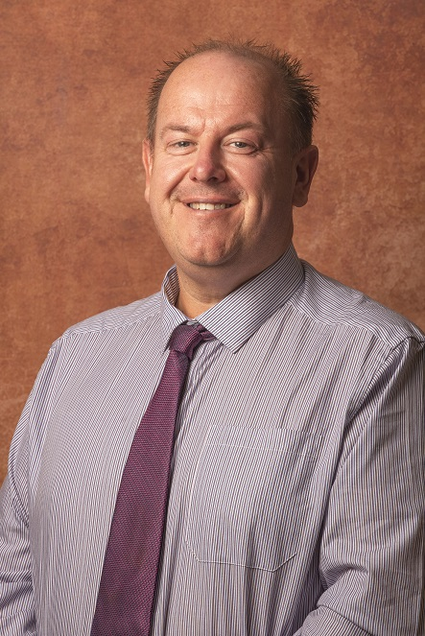

Our Senior Designated Person
is Mr K. Landrum
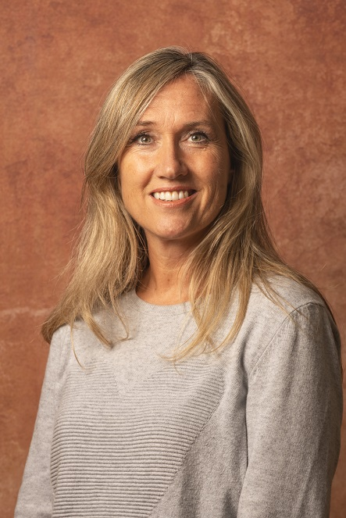

Our Deputy Designated Person
is Mrs J. McCallum


Our Assistant Designated Person
is Mr E. Naylor
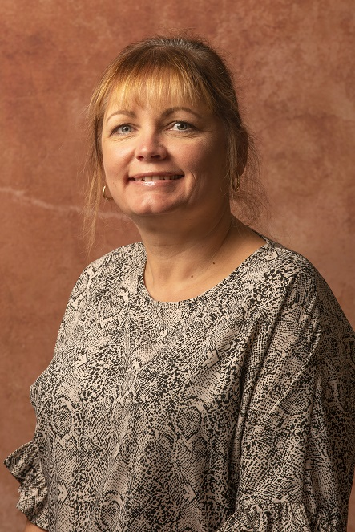

Our Assistant Designated Person
is Mrs P. Wright

If you have any queries regarding the information contained in this leaflet, or require further clarification of any points, please do not hesitate to contact
Mr K. Landrum.
St Gerard’s Catholic Primary & Nursery School
Lugsdale Road
Widnes
Cheshire
WA8 6DD

Tel: 0151 424 2879
Fax: 0151 424 4461
Email: head.stgerards@halton.gov.uk



Safeguarding Information and advice for volunteers and Outside Agencies
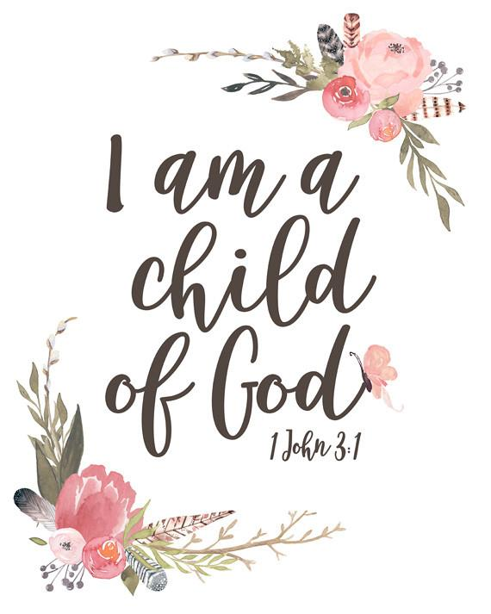

Guided by God, St. Gerard’s Catholic Primary & Nursery School is an inspiring and aspirational community where we learn to love, hope, dream and achieve

Aim of this leaflet
The leaflet is designed to provide you with some useful advice and information about safeguarding whilst at St. Gerard’s Catholic Primary & Nursery School. As a school we are committed to safeguarding and meeting the needs of children, young people and adults.

CRB/DBS Checks
Part of the Safeguarding Policy requirements is that volunteers and other outside agencies working in schools with children are checked by the Disclosure and Barring Scheme. The Headteacher will be able to advise you further on this and tell you more about their school code of conduct. If you have a CRB/DBS you should notify the School Office who will record the number on the schools central record. If you are not a regular visitor to the school and do not have a CRB/DBS it is very important that you are not left with children without supervision of a member of school staff. You should also in form the Headteacher if you become subject to a criminal investigation, caution or conviction. This helps to protect you as well as the young children in out care.

What are my responsibilities as a Volunteer?
All those that come into contact with children through school their everyday work whether paid or voluntary have a duty to safeguard and promote the welfare of children. In every school you will find a child protection policy document and it is very helpful to find out where it is and read it through.

Which children need protection?
You may become aware whilst working with a child that there are some problems at home or elsewhere that give you cause for concern. You may become aware of unexplained marks or bruising, changes in child’s behaviour or demeanour. Sometimes children display aggressive behaviour, become withdrawn and uncommunicative or unable to concentrate.

What should I do if I am worried about a child?
In every school there are designated members of staff trained in Child Protection who will know what to do. You should report any concerns to them immediately and they will deal with the matter in an appropriate way.

What should I do if a child discloses that he/she is being harmed?
Although the likelihood of this is small it is important to know what to do in such an eventuality:
- Listen to the child, without making
judgement.
- Take what they tell you seriously, children rarely lie about such matters.
- Explain that you can’t keep the information a secret and must pass it on to someone who will know what to do.
- Don’t interrogate the child and ask leading questions, such as “what to do next?”
- Try and convey to the child that they are not to blame for what has happened, though at the same time avoid criticising the abuser.
- Don’t make promises you can’t keep, but make sure you tell the child how well they are doing

What should I do next?
Find one of the designated members of staff immediately and pass on the information to them.

What should I do if the abuser is a member of school staff?
You should report such allegations to the Headteacher. If the allegation is about the Headteacher contact the Chair of Governors.

How do I assure that my behaviour is always appropriate?
Appropriate relationships with children should be based on mutual trust and respect. As a volunteer you may well be working closely with children sometimes on a one to one basis. Children, especially when they are young are often spontaneously affectionate and tactile and it is important not to alienate them through lack of response or by appearing to reject this. You should, however, be careful about physical contact.

If you are working with a pupil on his/her own always ensure the door is left open or that you can be visible to others.

Never make arrangements to meet a pupil on their own without school or parental permission.

Do not photograph pupils, exchange emails of text messages, or give out your personal details.

No child should suffer from harm, either at home or at our school. Everyone who works in our school has a responsibility to make sure that our young people are safe.

This leaflet has been given to you to make sure you understand what is expected of you. Please ask the person who gave it to you if you are not clear about anything in it, and keep this leaflet in a safe place so that you can read it again if you need to.



