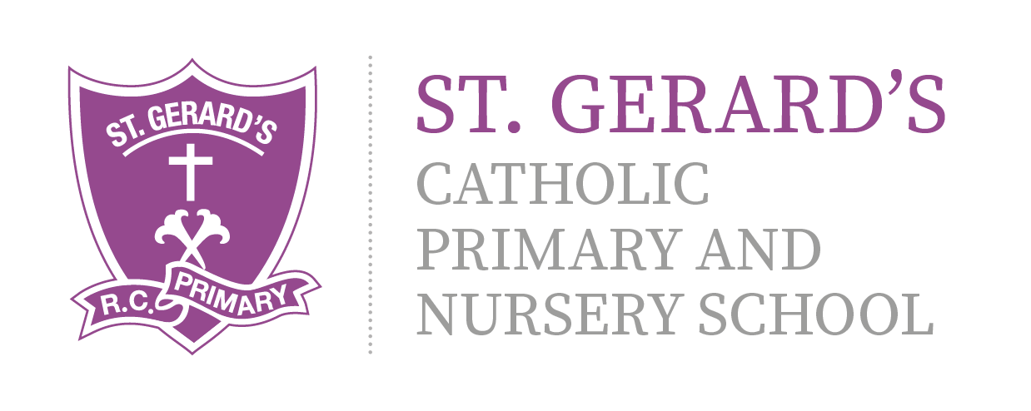

ST GERARD'S CATHOLIC PRIMARY & Nursery School
Science Development Strategy – Year 3 Key Skills
Ear
Topics to be covered by the End of Year 3:

Living things and their habitats

Identify the different parts of flowering plants.
Identify the main stages of the life cycle of flowering plants.
Children will be able to name the three different types of rocks.
They will handle and examine rocks to identify their properties, with support.
They will be able to state the four different types of matter that soil is composed of.

Forces and Magnets

Identify forces as pushes and pulls.
Describe friction as a force that slows objects down.
Feel the pulling force of a magnet.
Sort materials according to whether they are magnetic or not.
Participate in an investigation into magnet strength.
Identify the different poles of a bar magnet.

Animals, including humans

Understand that plants and animals obtain food in different ways.
Identify the right types and demonstrate they understand the right amounts of nutrients for animals including humans.
Name the different types of skeletons as well as identify and categorise animals based on the type of skeleton it has.
Identify the main bones in the body and how a skeleton protects, supports and helps the body to move.
Explain how pairs of muscles work together to enable movement.
Explain the different ways that plants and animals including humans obtain food.

Light

Identify light sources.
Understand that we need light to see.
Know that light travels in a straight line.
Identify reflective surfaces.
Know that the sun can damage their eyes.

Working Scientifically

Children will learn to make careful observations.
They will be able to take part in and contribute towards an oral presentation of their observations.
Predict what will happen in an investigation.
Make observations.
Construct a bar chart on labelled axes.
Form a conclusion from their results.
Identify bones in x ray images
Identify concave and convex mirrors as curved mirrors.
Identify devices and inventions that use curved mirrors.
Children will learn to make careful observations.

