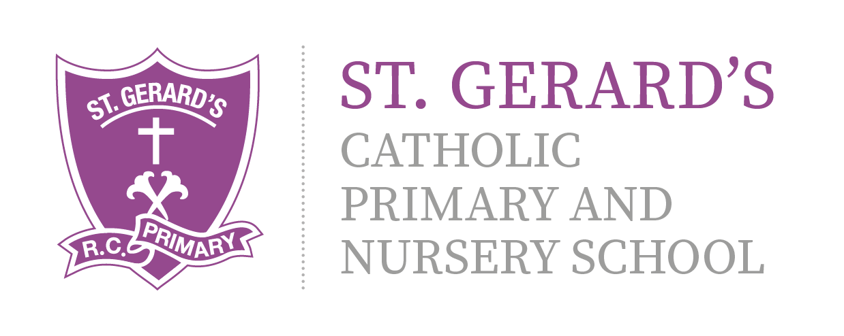

ST GERARD'S CATHOLIC PRIMARY & Nursery School
Science Development Strategy – Year 2 Key Skills
Ear
Topics to be covered by the End of Year 2:

Living things and their habitats

Explore and compare the differences between things that are living, dead, and things that have never been alive.
Identify that most living things live in habitats to which they are suited and describe how different habitats provide for the basic needs of different kinds of animals and plants, and how they depend on each other.
Identify and name a variety of plants and animals in their habitats, including micro-habitats.

Describe how animals obtain their food from plants and other animals, using the idea of a simple food chain, and identify and name different sources of food.

Plants

Observe and describe how seeds and bulbs grow into mature plants.
Find out and describe how plants need water, light and a suitable temperature to grow and stay healthy.
Observe and describe how seeds and bulbs grow into mature plants.
Find out and describe how plants need water, light and a suitable temperature to grow and stay healthy.

Animals, including humans

Notice that animals, including humans, have offspring which grow into adults.
Find out about and describe the basic needs of animals, including humans, for survival (water, food and air).
Describe the importance for humans of exercise, eating the right amounts of different types of food, and hygiene.

Uses of everyday materials

Identify and compare the suitability of a variety of everyday materials, including wood, metal, plastic, glass, brick, rock, paper and cardboard for particular uses.
Find out how the shapes of solid objects made from some materials can be changed by squashing, bending, twisting and stretching.

Working Scientifically

Asking simple questions and recognising that they can be answered in different ways
Observing closely, using simple equipment

Performing simple tests

Identifying and classifying

Using their observations and ideas to suggest answers to questions

