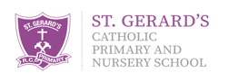

Pupil Parliament Minutes
Tuesday 10th October 2023

- Mrs Flint welcomed everybody.
- All children received a welcome letter, which detailed how being elected, is huge achievement that they should be proud of.
- Each child was presented with their badge.
- Mrs Flint read through the Code of Conduct and all agreed to abide by our expectations.
- We took photos for our display
Actions for the next meeting
- To start to think about what impact we can have on the school.

